**Data Analysis of depression dataset**

Depression

0 11565

1 16336

**Based on the above data it can be concluded that 16336 i.e. 58% people in population are in depression**

Gender

Female 7221

Male 9115

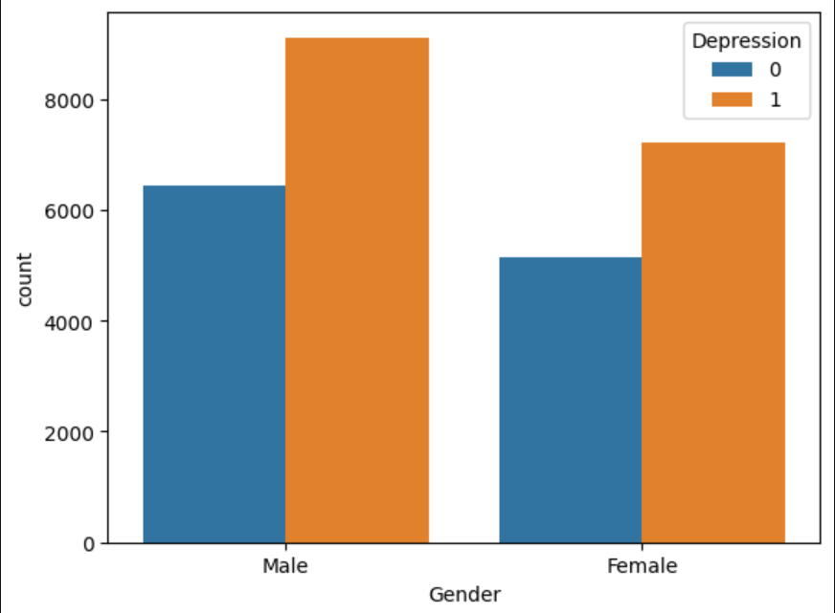

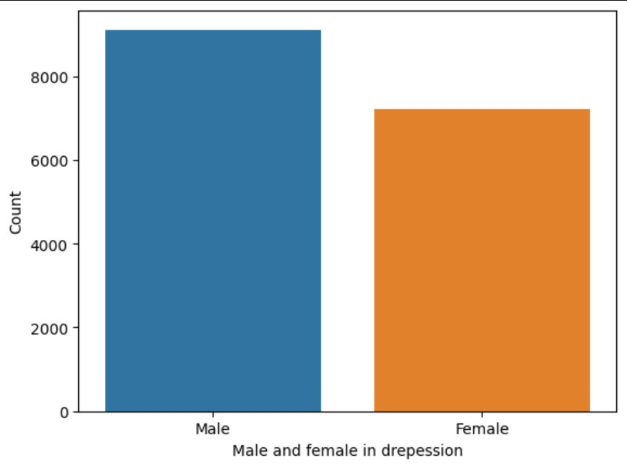

**Depression is observed more in males than females**

**Top 10 cities with highest number of depressed students:**

'Kalyan', 'Hyderabad', 'Srinagar', 'Vasai-Virar', 'Thane', 'Kolkata', 'Ludhiana', 'Lucknow', 'Ahmedabad', 'Patna'

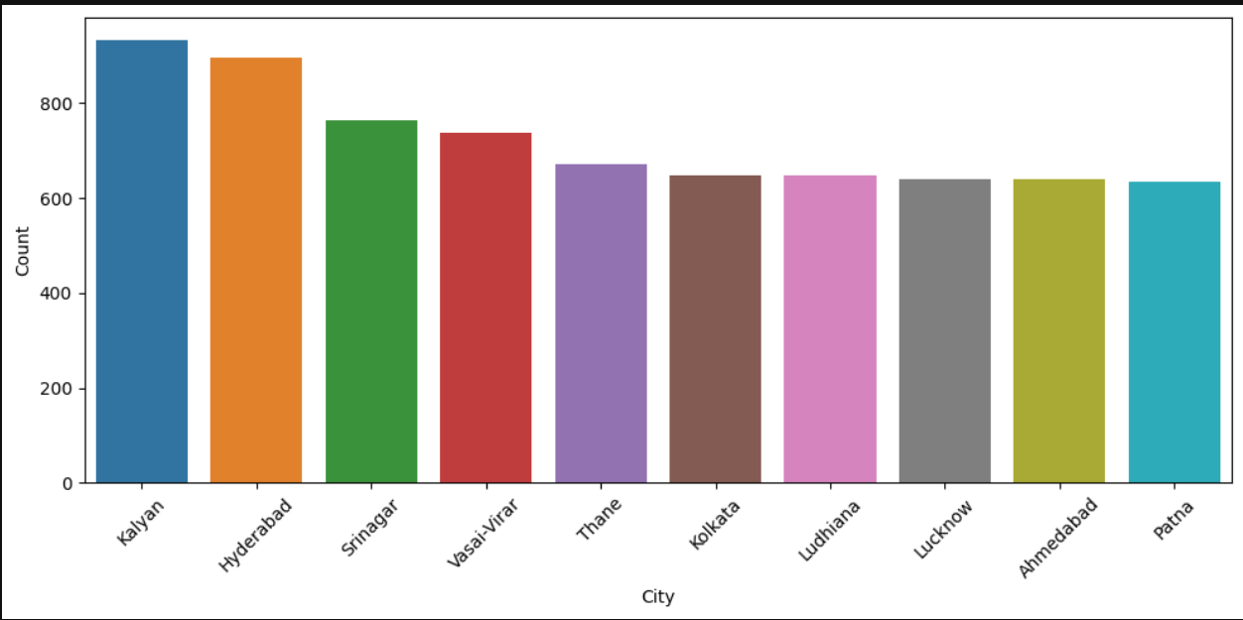

Kalyan has highest number of depressed people – 934, followed by Hyderabad – 879, Srinagar- 763, Vasai-Virar – 739 and Thane-673 and so on.

**Top 10 cities with student having no depression:**

'Kalyan', 'Srinagar', 'Vasai-Virar', 'Lucknow', 'Agra', 'Jaipur', 'Thane', 'Ludhiana', 'Surat', 'Hyderabad'

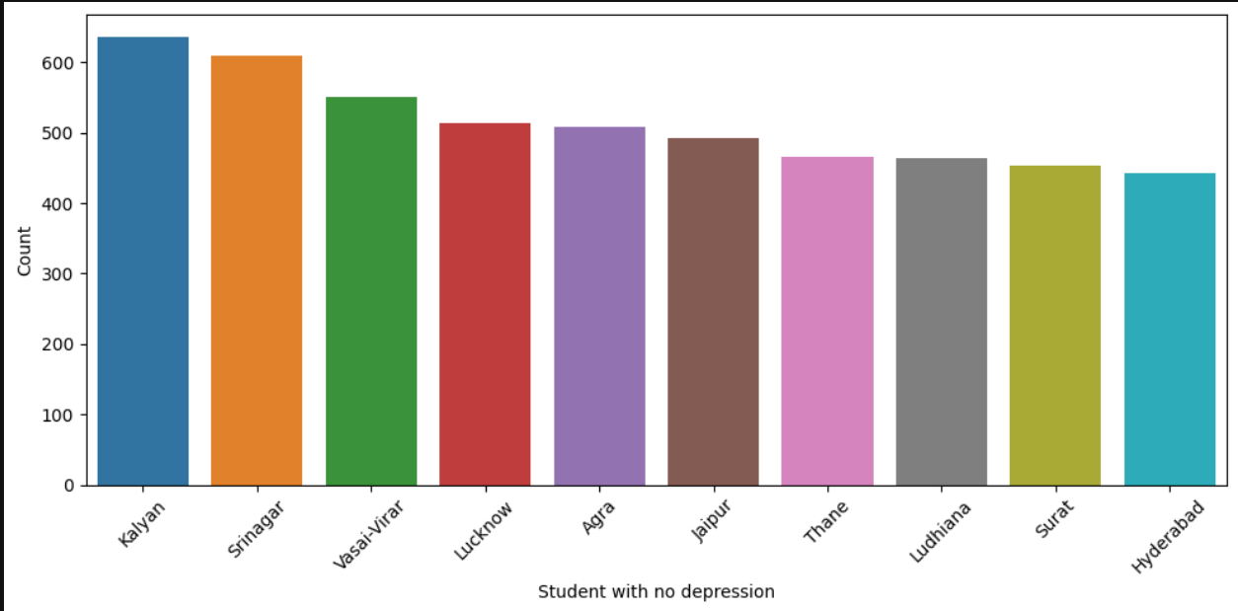

**The top 10 cities with the highest number of students showing lower levels of depression were identified. However, several cities appear in both the lists of high depression rates and low depression rates, suggesting overlapping patterns and indicating that depression levels may vary within different segments of the population in the same city**

**Analysing Depression by profession:**

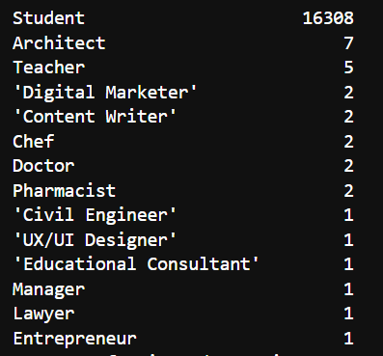

From the above analysed data it can be observed that out 16336 depressed people 16308 are students.

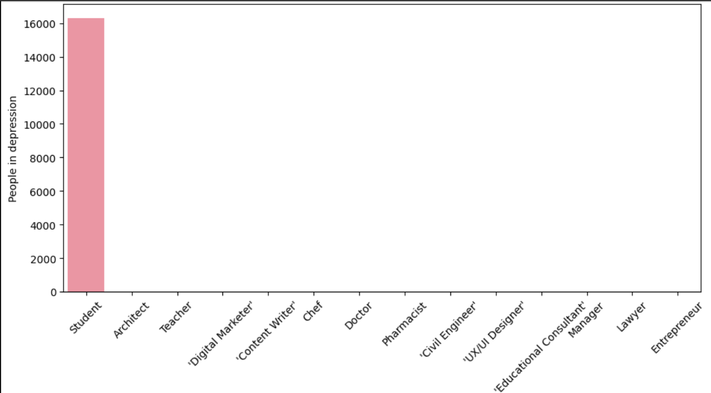

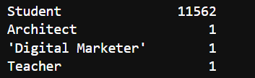

Out of 11565 non depressed people , 11562 are students .

Overall it can be observed majority of the students are facing depression problem .

**Analysing academic pressure:**

1. Overall academic pressure seems to average

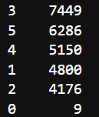

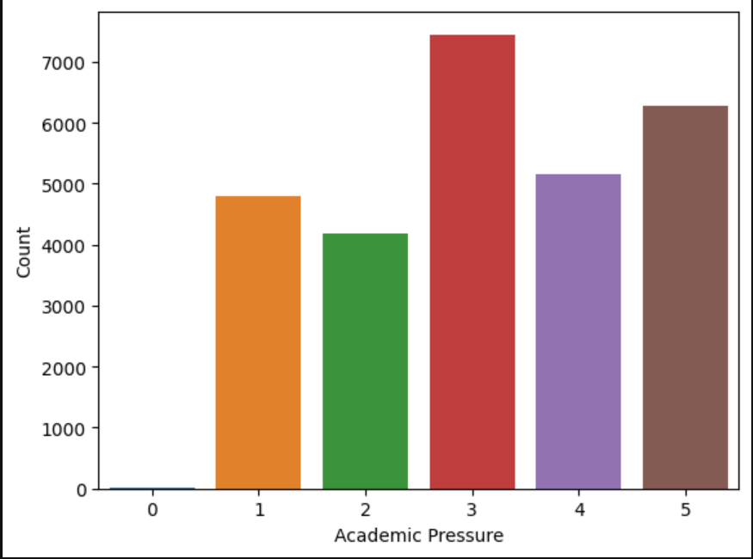

1. Most of the students who are in depression have high academic pressure or average academic pressure

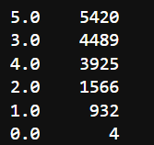

1. Students who are not suffering from depression are facing less academic pressure:

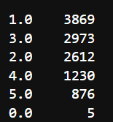

Note : In the group of Students with depression there still exists some students who have less academic pressure and in group of students who do not have depression still have some students who face high academic pressure.

**Analysing CGPA:**

Average CGPA : 7.65

Average CGPA of depressed student : 7.68 (More than Avg)

Average CGPA of non depressed students : 7.61 (Below Avg)

From analysis it can be observed that there exist 30 student who have highest CGPA i.e 10 yet they are facing depression.

**Analysing study satisfaction :**

Out of the students who are facing depression most of the students are not satisfied with studies , while the one who are not facing depression are observed to be satisfied with their studies .

**Sleep Analysis**

Most of Students facing depression tends to sleep less than 5 hours while most of them who not facing depression tends to sleep for 7-8 hours .

While there exist 4371 students who are facing depression yet they sleep for 7-8 hours and 2949 students who are not facing depression still sleep for 5-6 hours

**Dietary habits**

Most of Students facing depression tends to have unhealthy and moderate diet while the one who are not facing depression tends to have Healthy and moderate diet

**Degree:**

Majority of the students who tends to have depression are from class 12 followed by B ed

**Suicidal thoughts**

13957 students who are facing depression tends to have suicidal thoughts , while 2379 don’t. On the other hand 3699 students who are not facing depression still have suicidal thoughts

**Study hours**

Most of the students facing depression tends study for more hours (10 , 12 , 11) . While the one who are not facing depression tends to high and less hours (10 , 0 , 12)

**Financial Stress**

Students suffering from depression are also facing high financial stress while the one who are not facing depression are not facing much financial stress.

**Family History of Mental Illness**

Most of the Students facing depression have family history of mental illness while most of them who are not facing depression do not have any family history of mental illness.